CASE STUDY

ON AMAZON EBS



**INTRODUCTION**

* **Amazon Elastic Block Store (Amazon EBS)** provides block level storage volumes for use with EC2 instances. EBS volumes behave like raw, unformatted block devices. You can mount these volumes as devices on your instances. EBS volumes that are attached to an instance are exposed as storage volumes that persist independently from the life of the instance. You can create a file system on top of these volumes, or use them in any way you would use a block device (such as a hard drive). You can dynamically change the configuration of a volume attached to an instance.
* EBS volumes are particularly well-suited for use as the primary storage for file systems, databases, or for any applications that require fine granular updates and access to raw, unformatted, block-level storage. Amazon EBS is well suited to both database-style applications that rely on random reads and writes, and to throughput- intensive applications that perform long, continuous reads and writes. With Amazon EBS, you pay only for what you use.
* Amazon EBS provides the following volume types: General Purpose SSD, Provisioned IOPS SSD, Throughput Optimized HDD, and Cold HDD.
* You can create your EBS volumes as encrypted volumes, in order to meet a wide range of data-at-rest encryption requirements for regulated/audited data and applications. When you create an encrypted EBS volume and attach it to a supported instance type, data stored at rest on the volume, disk I/O, and snapshots created from the volume are all encrypted. The encryption occurs on the servers that host EC2 instances, providing encryption of data-in-transit from EC2 instances to EBS storage.

**HANDS ON**

**Step 1**: Type **ec2** in search bar of the management

console

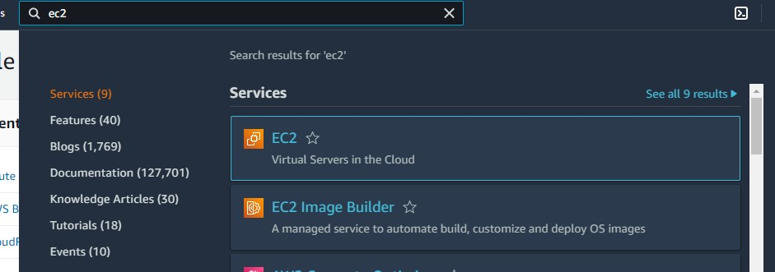

**Step 2**: Below interface will appear. Now from the left side go to **elastic block store** and click on volumes

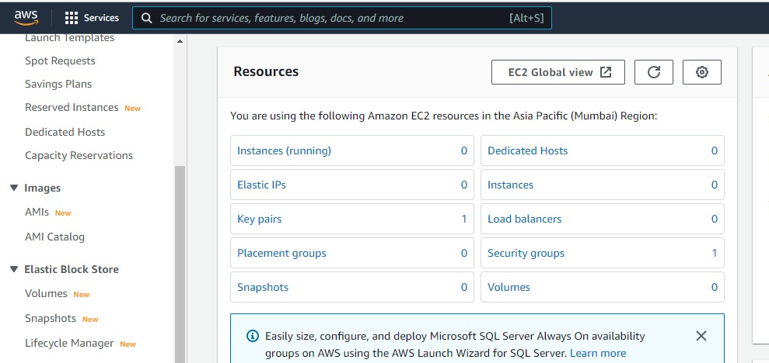

**Step 3**: Now click on **create volume**

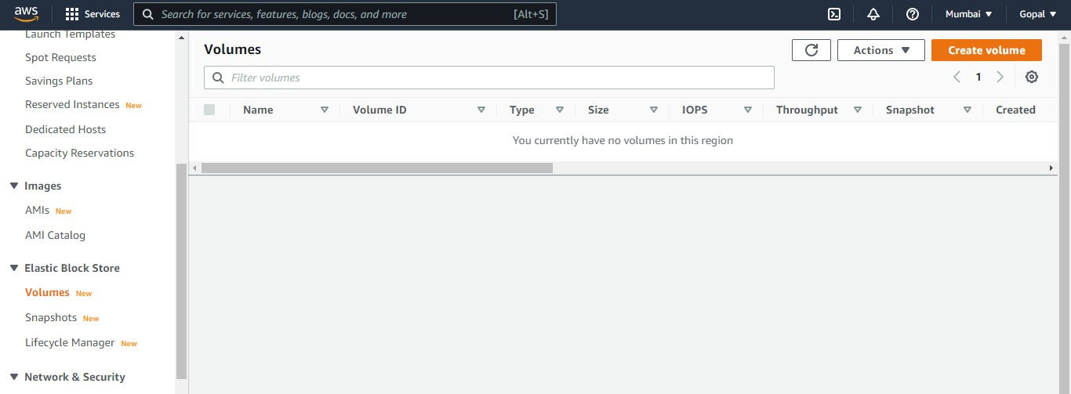

**Step 4**: Choose the volume type as per your requirement. For demo purpose I am **choosing General purpose ssd 2**

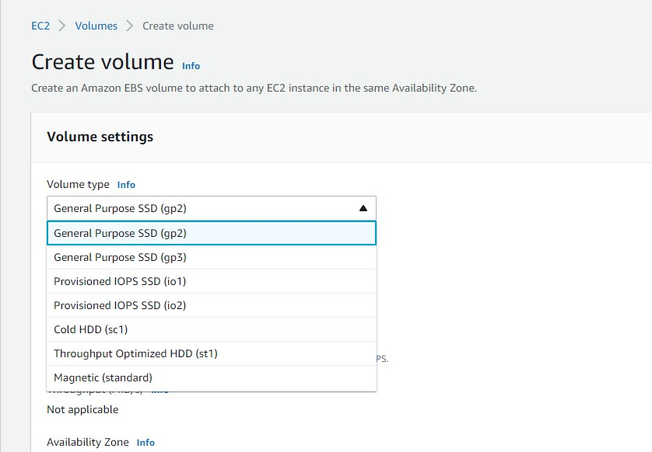

**Step 5**: Give the size, iops and AZ as per your requirement.

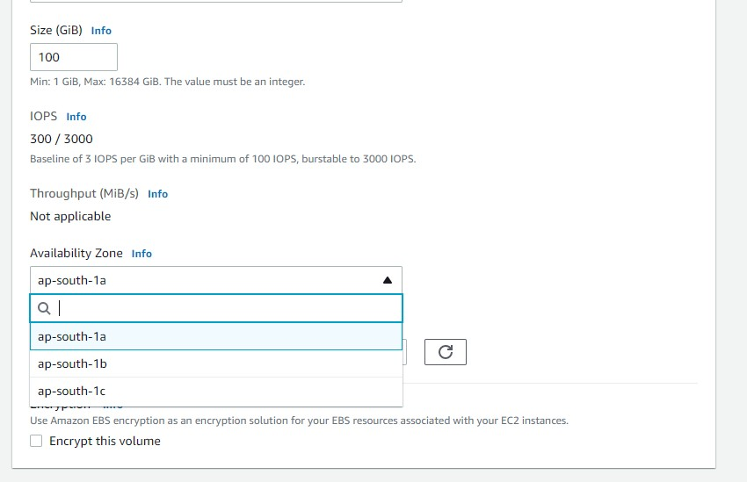

**Step 6**: Now click on create volume.

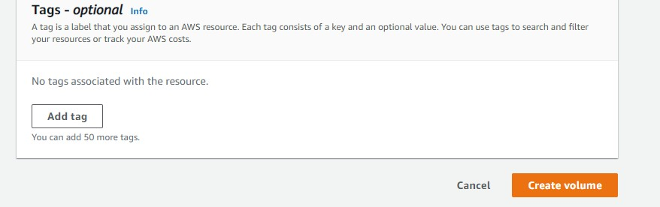

**Step 7**: You can see volume has been created

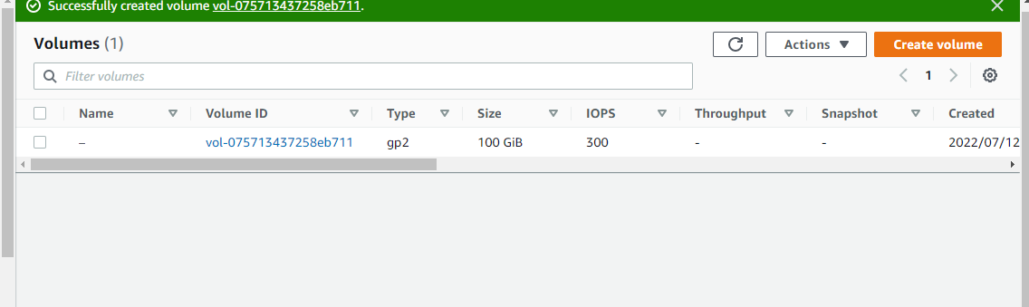

**Step 8**: Now inorder to attach this volume to an ec2 instance just select your volume and click on action, you will find attach option once your instance is created.

